

Counselling Issues &
Procedures

Counseling Issues and Procedures: Dealing with Present Trauma
Dr. Julie Ganschow

- Introduction
- Overcoming post-trauma distress begins with identity.
- Your functional identity is likely flawed.
- Your identity is built on lies enforced by parents or others who want you to think of yourself as
- A failure
- Unlovable
- Incapable
- Incompetent
- Dirty
- Unwanted
- Useless
- Overcoming post-trauma distress begins with gaining a new identity.
- Identity must be found in the gospel of Jesus Christ.
- You are a co-heir with Christ. Rom 8:17
- You are fearfully and wonderfully made. Ps. 139:14
- You are new creations in Christ. 2 Cor. 5:17
- You are adopted into the family of God. Eph. 1:4-5
- You have a permanent relationship with God. Eph. 1:13
- You are redeemed. Eph. 1:7
- You are forgiven. Eph. 4:32
- You have been made righteous. Eph. 2:1-10
- You are God's workmanship. Eph 2:10
- You are reconciled to God. Eph. 2:16
- You are a saint. Eph. 1:1
- You are chosen. Eph 1:4
- You are holy and beloved. Eph. 1:4-6
- You are a child of light. Eph. 5:8-10
- You have been made pure. Eph. 5:27
- You are blameless. Eph. 1:4
- You are above reproach. Eph. 1:4
- You are the glory of God and in the righteousness of God. Eph 2:1-10

- Develop A Biblical Perspective
- Foundational Counseling Principles.
- Understand the distress you feel is normal.
- Believe there is help, healing, and hope to be found in Christ and His Word.
- Accept that the Bible contains eternal truths that resolve the issues of the body and the soul that result from trauma.
- Realize Christ entered into your suffering with you. Matt. 26:36-43; Mark 14:33
"My soul is deeply grieved, to the point of death."
- Extreme responses to abuse and terror are normal. Ps. 38:10,17; 69:12
"My heart throbs, my strength fails me; and the light of my eyes, even that has gone from me."
- Extreme responses to soul-crushing and distressful events are normal. Ps. 55:4-5; Lam. 3:5-6; 17-18
"My spirit is broken, my days are extinguished, the grave is ready for me."
- Extreme responses to compromised physical health are normal. Job 30:16-17, 27
And now my soul is poured out within me; days of affliction have sieved me. At night it pierces my bones within me; and my gnawing pains take no rest."
- He empathizes with the distress, fears, and suffering you have experienced. John 19:23; Heb. 12:3
"For consider Him who has endured such hostility by sinners against Himself…"
- Focus on the gospel. Ps. 27
- Develop a biblical perspective on what you have suffered and come through it with a sound mind.

- Biblical Counseling and the PTS Survivor
- Common post-trauma responses
- Fear and Anxiety
- Post-trauma stress and anxiety is not a pathological condition.
- Post-trauma distress may bring medical complications due to a lack of sleep, fear, and anxiety.
- Biblically, post-trauma anxiety is understood as fear.
- Fear can serve a useful purpose. Ps. 111:10; Prov. 1:7; 22:3; Isa. 41:13
"The fear of the Lord is the beginning of wisdom."
- Fear is a normal emotional reaction to imminent danger.
- Fear and anxiety are responses to what is perceived as dangerous or potentially harmful.
- Post-trauma fear occurs when no threat exists.
- Post-trauma fear and distressing emotional responses become pronounced in the aftermath.
- Visual memories, recurrent nightmares, flashbacks, panic, physical exhaustion, body memories, etc.
- It feels as though the trauma just occurred.
- You fear it will happen again.

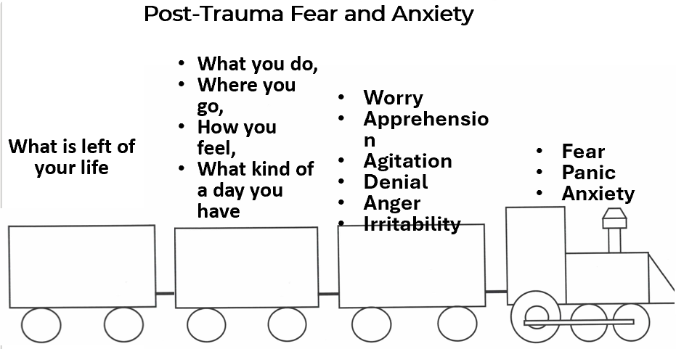

- PTS is an issue of the heart
- Identifying Post-trauma anxiety and stress biblically allows for the correct understanding and solutions for what you are experiencing.
- The Bible identifies you as a single being with two components
- The body (outer self/material/physical)
- The Heart (inner self/immaterial/soul/ thoughts/beliefs/ desires/will/ conscience, etc.
- The body and the heart affect each other.
- Fear and anxiety are created in the heart (inner self). Ps. 94:19; 55:1-3
- The problem is not the emotion of fear but the reason for the fear.
- Post-trauma fear and anxiety is a form of vigilance that attempts to maintain control for self-protection.
- Self-protection is rooted in self-sufficiency.
- Vigilance minus faith in God.
- Interpret your fear in light of God's Word.
- Framing your struggle biblically provides hope and comfort.
- Christ knows your difficulties and your pain.
- Christ calls you to come to Him for rest and relief from your fear and anxious burdens.
Come to me, all of you who are weary and burdened, and I will give you rest. Take my yoke upon you and learn from me, because I am lowly and humble in heart, and you will find rest for your souls. For my yoke is easy and my burden is light. Matt. 11:28-30 CSB

- Practical Application to Post-Trauma Fear
- Overview of the process of biblical change.
- Rule out biological causes for anxiety.
- Understand that fear, worry, and anxiety are habits that develop over time and with repetition.
- Overcoming post-trauma fear is not something that fundamentally changes overnight.
- Change will come as you understand the root of your feelings of fear and anxiety.
- Put into practice the process of biblical change.
- Fear as a diagnostic of the heart
- Fear is helpful because it's a powerful diagnostic.
- Fear exposes what we most value (2 Tim. 3:1-5; Matt. 22:36-40)
- Fear the nature of our treasures (James 5:13-16; Jer. 33:6; Ps. 3:5; Phil. 2:5-9
- Fear exposes our unbelief. Rom. 8:28-29; Matt. 6:25-34
- Fear exposes our self-centeredness.
- Fear exposes our need for control, Phil. 2:4; Luke 9:23-25
- Fear exposes past wounds or difficult experiences (Eph. 1).
- Fear exposes our pride (Phil. 2:5-9; 1 Cor. 10:24; 13:5; Ps. 31).
- To overcome any sin habit, we must put off the old practices, be renewed in our mind or heart, and put on the new practices (Eph. 4:22-25)
- Put off the old man- V22
- Utilize a Thought Journal or Disciple Prayer Journal.
- Ask yourself diagnostic, heart-level questions, examine my thoughts, and discern the truth about myself and my circumstances.
- Is there a valid reason to panic, or will staying calm be more helpful to me?
- Am I thinking about things that are true and real or imagined?
- What am I focusing on right now?
- Do I believe God is in control of this person or situation?
- What specifically am I thinking about right now?
- Is there anything I can do to address the situation that is leading me toward fear/panic?
- Am I unknowingly thinking about things contributing to how anxious, fearful, and worried I feel right now?
- Am I unknowingly thinking thoughts leading me to have this physical reaction in my body?
- What can I do to stop this fear/panic process now before it goes too far?
- What's the worst thing that will happen to me if I actually have a panic attack?
- Have I stopped thinking about God and his sovereign control over the situation?
- What am I thinking about instead of thinking about God and his sovereign control over the situation?
- Will thinking these anxious thoughts help or hurt my ability to handle the real issues that are going on?
- Renew your mind (Eph. 4:23; Rom. 12:2; Col. 3:10)
- Focus on the Truth ( John 17:17; Phil. 4:8-9).
- Repent.
- Repentance is critical in overcoming any sin.
- "Repentance" is an ongoing activity requiring daily concentrated effort.
- Have a change of mind about your fear and anxiety (Matt. 3:2; Mark. 1:15; 1 John. 4 18).
- Have a change of heart with respect to the sin of worry and anxiety (Matt. 6:33 Ps. 112:1, 7- 8).
- Put on the new man [Make a change in the course of life] (Eph. 4:24).
- Take every thought captive (1 Cor. 10:5)
- Focus on the love of God (1 John 4:18)
- Focus on the faithfulness of God (Isa. 41:10)
- Focus on the promises of God (Heb. 13:5-6; Ex. 34:6,7; Ps. 121; Prov. 3:1-26)
- Study Bible doctrine
- Justification (Rom. 8:33)
- Perseverance of the saints (Phil. 1:6)
- Union with Christ (Rom. 6:3-6)
- Forgiveness (Ps. 103; 1 John 1:7-9. 2:12)
- Fear with a purpose
"Neither this man nor his parents sinned," said Jesus, "but this happened so that the works of God might be displayed in him (John 9:3) (NIV)
- Consider that God ordains your sufferings with post-trauma fear and anxiety for God's glory and your sanctification.
- Sometimes, the victory is in the pursuit of Christ despite the difficulties and obstacles.
- Welcome adversity as a friend (James. 1:2-4)
- Find the rest, refuge, and peace found in God alone. Ps. 62:1–2, 91:1, 94:19, 116:7; Isa. 40:1-2, 66:13; 1 Cor. 1:3-4; John 14:18)

