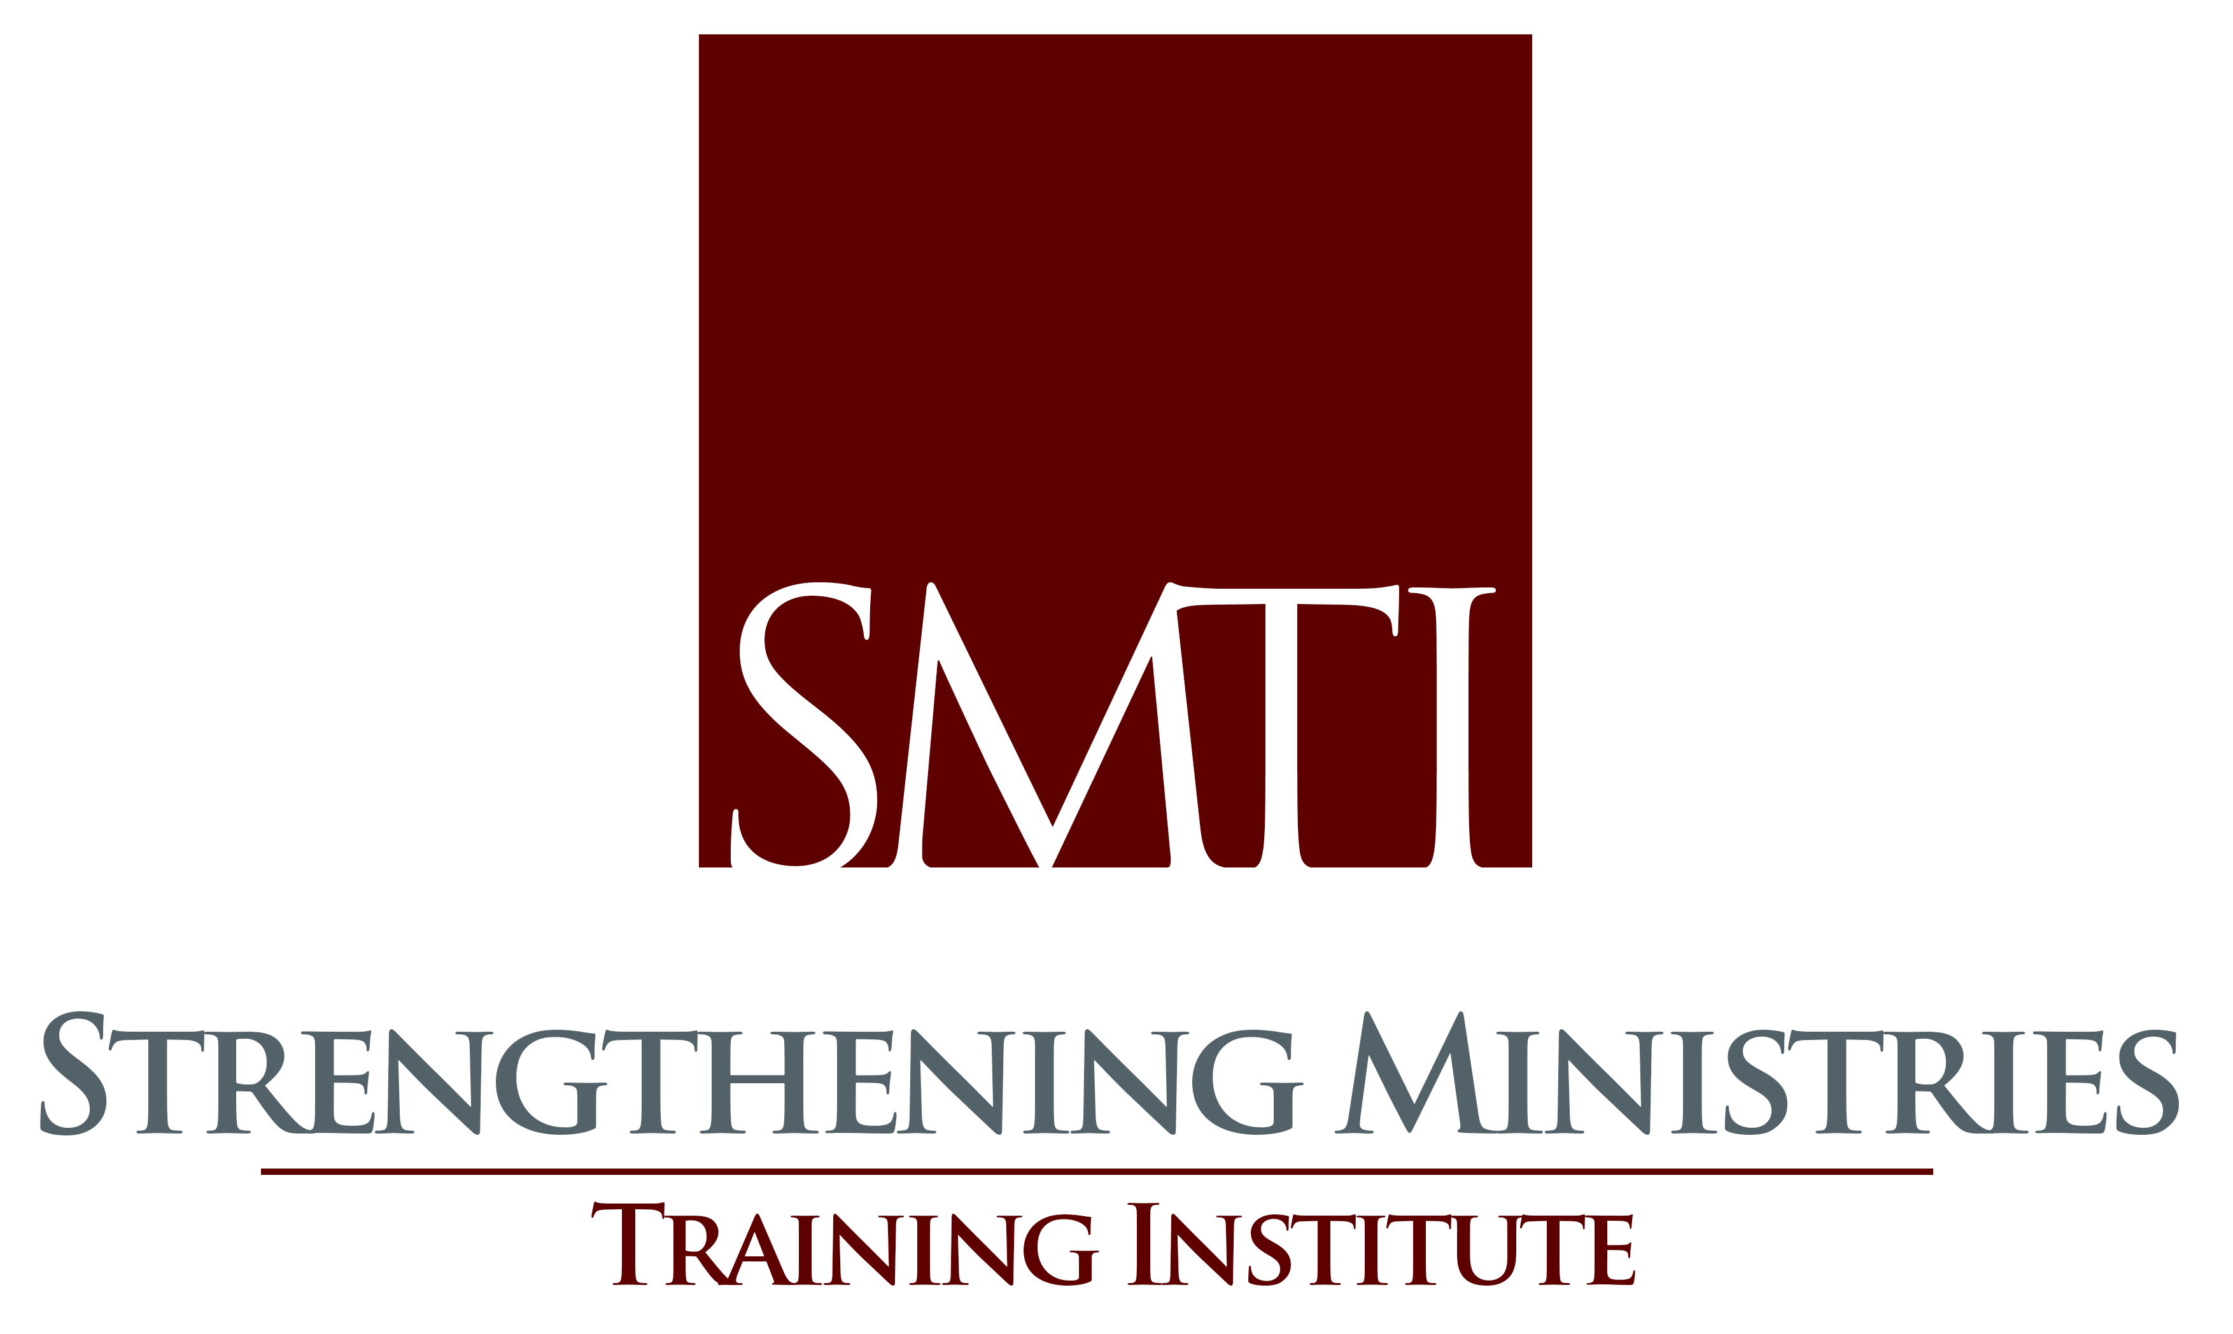

Counselling Issues &
Procedures

How to Help “Psychologized” Counselees
Pastor Timothy A. Pasma

Introduction
- What do you do when someone comes to you who uses the latest psychological labels?

- How can you really help a person who believes that such diagnostic labels are accurate in explaining his condition?

- Understand Who “Psychologized” Counselees Are

A. We are not referring to those who form the diagnostic labels and psychological categories of explanation.

B. We are referring to those who have absorbed or adopted these diagnostic labels and psychological categories to explain their particular challenges.

C. “Julia”

- Understand The Diagnostic Labels Of Psychologized Counselees

A. Diagnostic labels have a particular trajectory.

- Diagnostic labels have a trajectory that leads to any number of places/goals.

- A biblical understanding of the problems always lead to
Christ.

B. Diagnostic labels express particular worldviews.

1. Definition of a worldview.

2. The “Autonomous” worldview.

3. The “Servant” worldview.

4. Diagnostic labels reveal a worldview.

C. Diagnostic labels seek to explain three components of human behavior and identity.

1. Causality

2. Agenda

- Meaning/Interpretation

D. Diagnostic labels have predictable characteristics.

1. They produce faulty interpretation.

2. They produce faulty description.

3. They produce faulty prescription.

- Understanding How To Minister To Psychologized Counselees

A. Remember that you are counseling a person, not a theory.

B. Communicate care.

C. Listen more to the “story” than the labels -

- Realize that you are more like this person than you are different.

D. Get to know the person.

E. Thoroughly reinterpret the person’s world.

Conclusion

- A biblical interpretation of life’s experiences will always prove to be more broad and deep and more robust than any diagnostic label or psychological category of interpretation.

- Therefore, minister the Word of God to “psychologized” people!

David Powlison, “How to Help a ‘Psychologized’ Counselee,” a workshop presented at the Annual Conference of the National Association of Nouthetic Counselors, October 7, 2002.
Ibid.

